


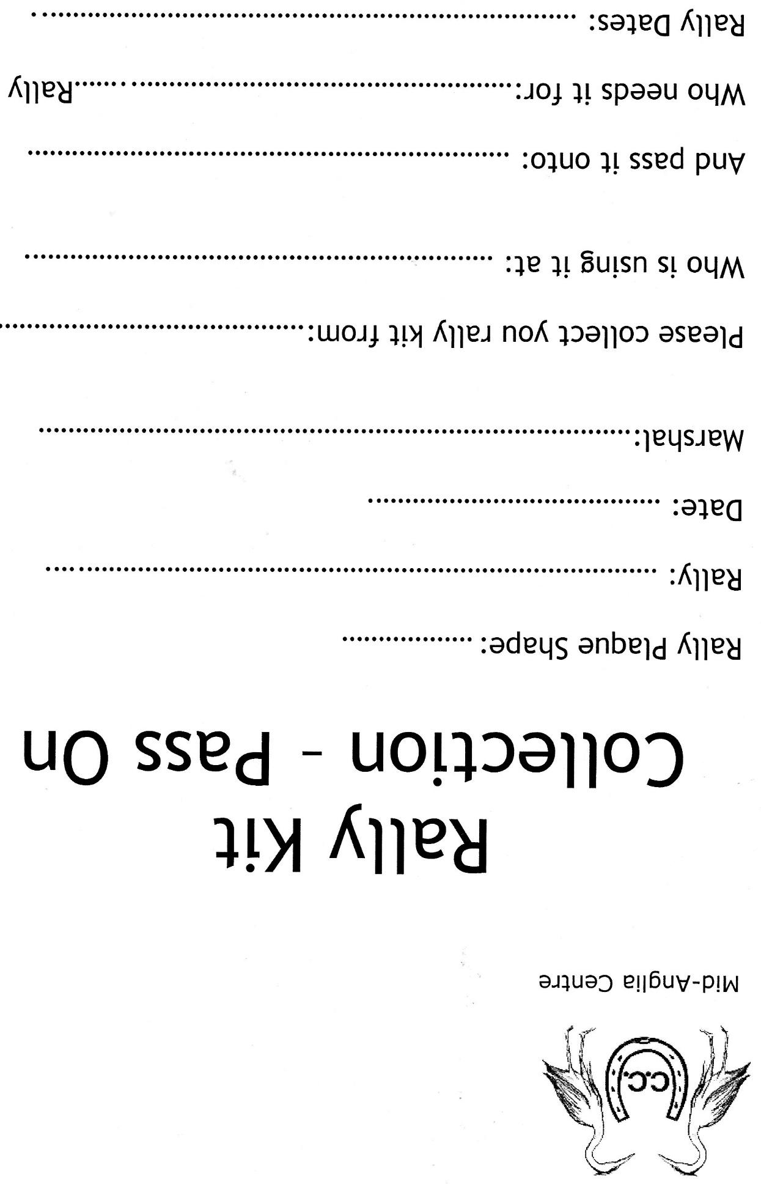

Any spare, or unissued, rally plaques to be returned to the Social Secretary together with the attendance record sheet.

