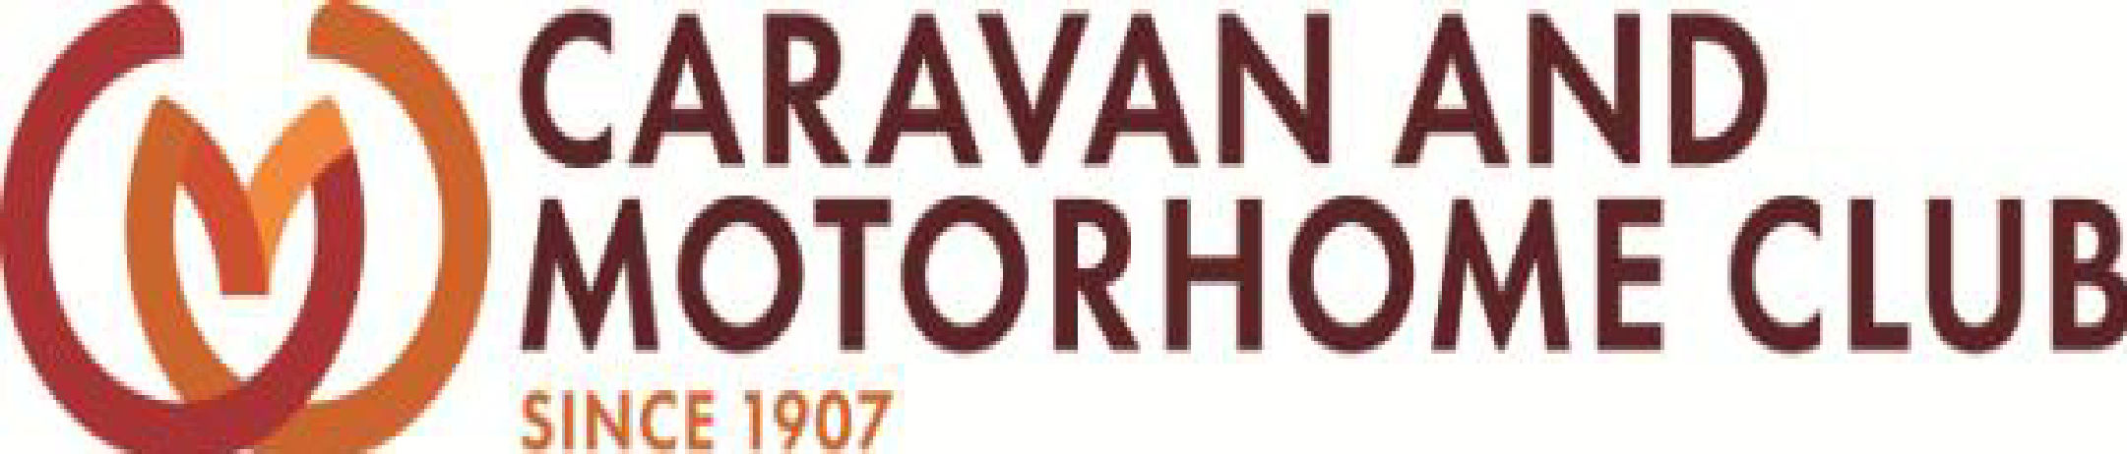
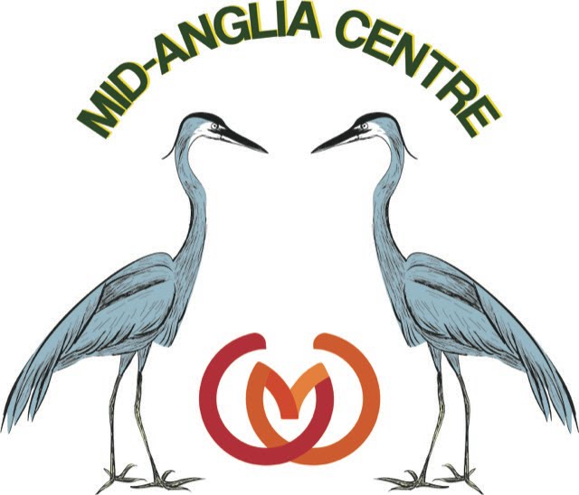

MID ANGLIA CENTRE – GUIDANCE NOTES

Your responsibilities as a food handler

You can pass on germs when you handle food. To prevent this you must:

Wash your hands thoroughly using warm, soapy water:
  - After using the toilet, at home and at work.
  - Before starting work, after breaks
  - After handling raw food
  - After handling rubbish

And dry your hands after you have washed them.

Do not handle food if you:
- Have been sick (vomiting)
- Have diarrhoea
- Have infected (red, swollen pus-containing) sores or cuts
- Feel unwell
- Were ill while recently on holiday
- If anyone in your household is sick or has diarrhoea

IF YOU HAVE SICKNESS OR DIARRHOEA, IT MAY BE CAUSED BY A GERM; YOU MUST NOT HANDLE FOOD UNTIL YOU ARE BETTER

Typhoid and paratyphoid
Typhoid and paratyphoid fever are rare but serious illnesses. You must not handle food if you think you have been in contact with either of these diseases

Your checklist for good hygiene practice:
  - Wash your hands thoroughly after going to the toilet and before handling food
  - Do not handle food if you are suffering from diarrhoea and/or vomiting
  - Do not handle food if you or anyone in your household is ill
  - Use blue, waterproof coverings for cuts and grazes
  - Do not spit, smoke, eat or chew gum when you are handing food
  - Make sure that your work clothes are clean
  - Keep your workplace, especially surfaces and utensils, clean
  - Do not handle food if you were ill while on holiday
  - If you must visit the doctor, remember to say you are a food handler

